PHASE 2 REPORT
Student Performance Prediction System
Project ID: AIML-11

Name | Class Roll No. | University Roll No. | Section & Group
ARPIT PANWAR___ | 37 | _2028662_____________ | Q G1____________
ADITYA BUTOLA_______ | 1___________ | _2028380__________ | Q G1_______________
ANUBHAV SINGH ___________________ | _34__________________ | _2028641_________________ | Q G1___________________

1. Problem Description
The Student Performance Prediction System is a Machine Learning based project designed to predict the academic performance of students using educational and behavioral data. Educational institutions often struggle to identify weak students at an early stage due to the large amount of academic information generated during the learning process. This project aims to solve this issue using predictive analytics and supervised Machine Learning algorithms.
The system analyzes various parameters such as attendance percentage, study hours, assignment submission records, internal marks, participation level, and previous academic performance. Using these features, the system predicts whether a student is likely to perform well or may require additional academic support.
The project helps teachers and institutions make data-driven decisions and provides a practical implementation of Machine Learning concepts including data preprocessing, feature engineering, model training, evaluation metrics, and visualization.

2. Steps of Implementation
- Collection of student academic dataset from CSV files.
- Cleaning and preprocessing of raw data.
- Handling missing and duplicate values.
- Feature selection and normalization.
- Exploratory Data Analysis using graphs and plots.
- Training Machine Learning models.
- Evaluating model performance using metrics.
- Generating prediction results and visualizations.

3. Proposed Modules
Data Collection Module: Used to collect and import student records and academic datasets into the system.
Data Preprocessing Module: Responsible for handling missing values, encoding categorical features, and scaling numerical data.
Visualization Module: Generates graphs, heatmaps, and statistical plots for data analysis.
Model Training Module: Implements Machine Learning algorithms such as Logistic Regression, KNN, SVM, Decision Tree, and Random Forest.
Prediction Module: Predicts the future academic performance of students based on trained models.
Evaluation Module: Measures model performance using Accuracy, Precision, Recall, F1-Score, and Confusion Matrix.

4. Flow Diagram
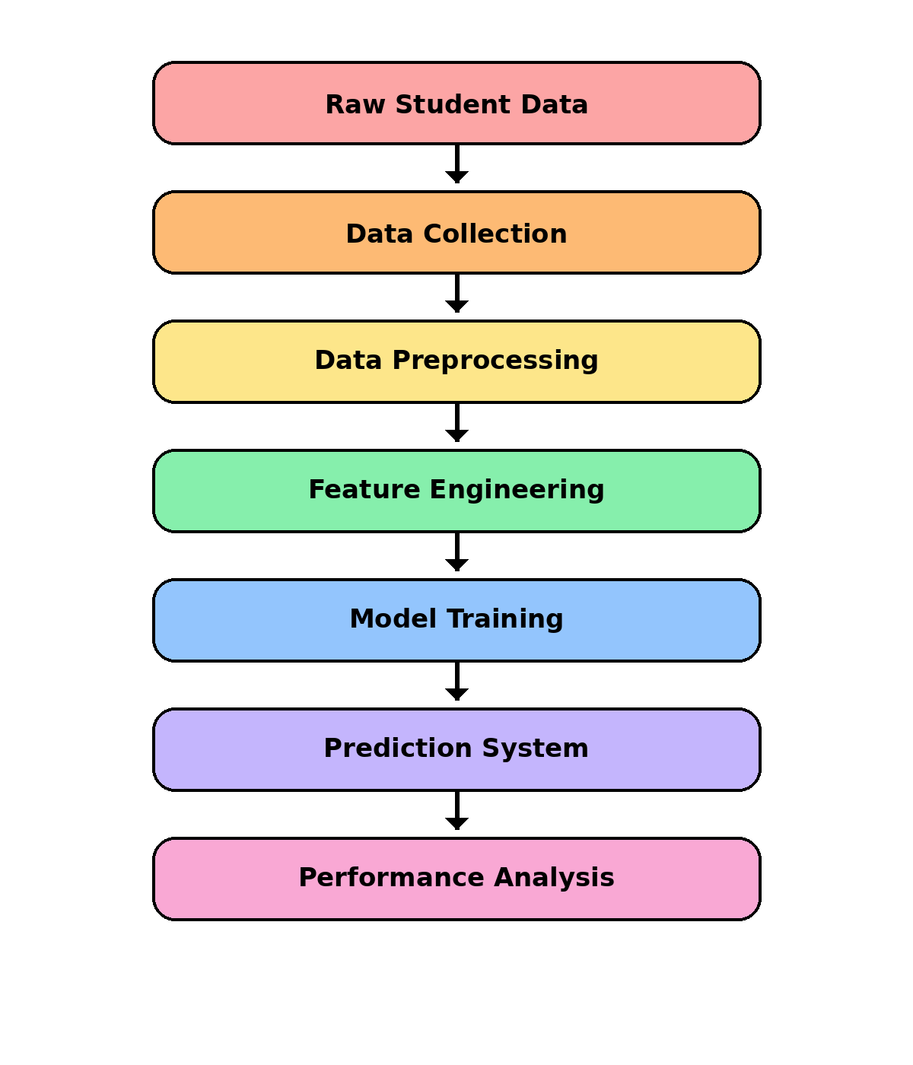
Fig.1 Workflow Architecture of Student Performance Prediction System

5. Required Topics from Subject
Python Programming: Python is used as the primary programming language because of its simplicity and extensive Machine Learning libraries.
Machine Learning: Supervised Machine Learning algorithms are used for prediction and classification of student performance.
Data Structures: Lists, arrays, and dataframes are used to manage and process student records efficiently.
File Handling: CSV files are used for reading and storing dataset information.
Data Visualization: Libraries such as Matplotlib and Seaborn are used to visualize data patterns and trends.

6. Platform Required
- Visual Studio Code – Used for coding, debugging, and project development.
- Jupyter Notebook – Used for data analysis and visualization.
- Google Colab – Used for cloud-based Machine Learning execution.
- Python Environment – Used for implementing Machine Learning algorithms.

7. Books and Link Sources
- Let Us Python – Yashavant Kanetkar
- Python Machine Learning – Sebastian Raschka
- https://www.geeksforgeeks.org/
- https://www.kaggle.com/
- https://scikit-learn.org/
- https://stackoverflow.com/

